PROJECT PROPOSAL
Robotic Vision Pick System
Custom Stereo Vision & Intelligent Pick-and-Place Automation
Prepared for: [Client Name] | Prepared by: [Your Company] | Date: 2025

Executive Summary
Today's commercial machine vision systems were built for large-scale robotics deployments at Tier 1 manufacturers — and priced accordingly. Smaller and mid-market manufacturers are left with solutions that are too expensive, too rigid, and fundamentally limited by single-camera 2D vision that cannot reliably determine where a part is in three-dimensional space. The result is slow cycle times, frequent pick failures, and systems that break down when parts change.
This proposal outlines the design, implementation, and estimated cost of a custom stereo vision system that addresses this gap directly. Using off-the-shelf industrial cameras, open-source software, and a CAD-informed pose estimation pipeline built on existing SolidWorks part data, the system achieves reliable sub-second pick cycles with full self-diagnostic capability. The architecture is camera-vendor-agnostic, field-maintainable, and designed for production deployment at a fraction of the cost of incumbent solutions.
This document also includes a Market Opportunity & Productization Path section (Part II) which outlines the commercial case for productizing this system, the go-to-market strategy, and the industry partnerships — with camera manufacturers, robot arm vendors, and distribution channels — that would accelerate adoption.

Contents
1. Problem Statement 3
2. Objective 4
3. Technical Approach 4
2.1 Why Custom Stereo vs. Proprietary Depth Cameras 4
4. System Architecture — Visual Summary 5
4.1 Runtime pick cycle 5
4.2 Offline preparation vs. runtime execution 5
4.3 Full component stack 6
5. Hardware Architecture 7
5.1 Camera Selection 7
5.2 Compute 7
5.3 Calibration Target 7
5.4 End Effector 7
6. Software Architecture 8
6.1 Stack Overview 8
6.2 Offline Preparation Pipeline (Per Part) 9
6.3 Runtime Pick Cycle 10
8. Diagnostics & Calibration Health 10
8.1 Stage 1 — Stereo Camera Calibration Check 10
8.2 Stage 2 — Hand-Eye Calibration Check 11
8.3 Stage 3 — Golden Part Verification (Optional) 11
8.4 Diagnostic Schedule 11
8.5 Diagnostic Logging 11
9. System Features 12
9.1 Core Features 12
9.2 Operational Features 12
9.3 Optional / Future Features 12
10. Estimated Cost 13
10.1 Hardware 13
10.2 Software Development 13
10.3 Proof of Concept Phase 14
11. Risks & Mitigations 15
12. High-Level Project Timeline 15
13. Next Steps 16
14. The Market Opportunity 17
14.1 The Incumbent Problem 17
14.2 The Underserved Segment 17
14.3 Why This Architecture Wins in That Segment 18
15. Productization Path 19
15.1 What Needs to Be Built 19
15.2 Three-Phase Go-to-Market 20
15.3 Competitive Positioning 20
15.4 Go-to-Market Partnerships 21
16. Recommendation & Next Steps 22
Vision & Depth Sensing 23
Software & Algorithms 24
Robotics & Motion 25

1. Problem Statement
Robotic pick-and-place automation has historically been the domain of large manufacturers with dedicated automation engineering teams and capital budgets to match. The vision systems that power these robots reflect that reality: they are expensive, complex to configure, slow to adapt to new parts, and sold through integrator networks that add further cost and lead time.

For small and mid-market manufacturers — job shops, contract manufacturers, and flexible production cells — these solutions are effectively out of reach. What exists at accessible price points is a generation behind in capability. The dominant approach in lower-cost vision systems is single-camera 2D image capture: the robot's camera takes a flat photograph of the pick surface and attempts to infer part position from pixel coordinates alone.

This approach has three fundamental limitations that compound in production:

Limitation | Real-World Impact
No depth perception | A flat image cannot tell the system how high a part is sitting, how it is tilted, or whether it is resting on another part. The robot approaches at a fixed Z height and either misses or damages the part. Pick reliability degrades sharply with any variation in how parts are presented.
No 3D pose estimation | Without a full 3D pose — position and orientation in six degrees of freedom — the system cannot reliably place the suction cup on the correct contact point. Parts that are rotated, tilted, or partially occluded cause failures that require manual intervention to recover.
Slow and brittle | Single-camera systems compensate for poor spatial data with slower, more conservative approach motions and larger pick tolerances. Part changeovers require reprogramming by an engineer. Lighting changes, surface finishes, and minor part geometry variations can invalidate the entire configuration.

The result is that manufacturers who cannot afford enterprise-grade vision systems are left choosing between unreliable automation and no automation at all. Cycle times are slow, pick failure rates are high, and the operational burden of maintaining and reconfiguring these systems erodes the economic case for deployment.

This proposal describes a stereo vision system designed specifically to close this gap: enterprise-grade 3D pick accuracy at a cost and complexity level accessible to mid-market manufacturers, built on a CAD-informed architecture that leverages the SolidWorks part data these manufacturers already have.

2. Objective
The objective of this project is to design and deploy an intelligent robotic pick-and-place system capable of:
- Identifying known parts from a defined catalog using stereo depth vision
- Estimating the 3D pose of each part relative to the robot base frame
- Commanding a robotic arm with a suction cup end effector to pick parts from a presentation platform and place them at a target location
- Completing the full detect-plan-pick-place cycle in under one second per part
- Self-diagnosing calibration health and alerting operators to drift or failure before pick accuracy degrades

The system is designed around a known parts catalog sourced from existing SolidWorks CAD data, enabling the majority of computationally expensive work to be performed offline. Runtime processing is therefore a matching and lookup problem rather than an inference problem, resulting in lower latency, higher reliability, and more deterministic behavior than general-purpose bin-picking solutions.

3. Technical Approach
The system is built on four core design principles:

CAD-Informed | Part geometry, optimal suction grasp points, and pose reference models are computed offline from SolidWorks STL exports. Runtime processing is matching, not learning.
Off-the-Shelf Hardware | Industrial global-shutter cameras (e.g. FLIR Blackfly S or Basler ace) replace proprietary depth camera units. Hardware sync via GPIO eliminates rolling-shutter artifacts. No vendor lock-in.
Open-Source Stack | OpenCV, Open3D, PyTorch, and ROS2 form the core software stack. All components are actively maintained, have large communities, and carry no per-deployment licensing costs.
Self-Certifying | The system runs automated calibration diagnostics at startup, on schedule, and on anomaly detection. It knows its own accuracy state at all times and escalates to operator intervention only when outside self-correction range.

2.1 Why Custom Stereo vs. Proprietary Depth Cameras
Off-the-shelf depth cameras such as the Intel RealSense D435i are well-suited for prototyping but carry risks for production deployment: Intel has wound down the RealSense consumer product line, creating long-term supply uncertainty. Building on calibrated industrial cameras with an open software stack eliminates vendor dependency, provides full control over every pipeline parameter, and allows the camera geometry to be adapted to the specific mounting constraints of the installation rather than a fixed housing form factor.
The tradeoff is that stereo calibration and depth computation must be owned by the project. This proposal addresses that directly through hardware sync, robust calibration tooling, and automated recalibration diagnostics.

4. System Architecture — Visual Summary
The following diagrams provide a graphical overview of the three key architectural views: the runtime pick cycle, the offline vs. runtime layering, and the full component stack.

4.1 Runtime pick cycle
Left-to-right flow from stereo capture through detection, pose estimation, and motion planning to the robot arm. The CAD offline library feeds into the runtime pipeline. Vision stages overlap with arm return transit to maximize throughput.

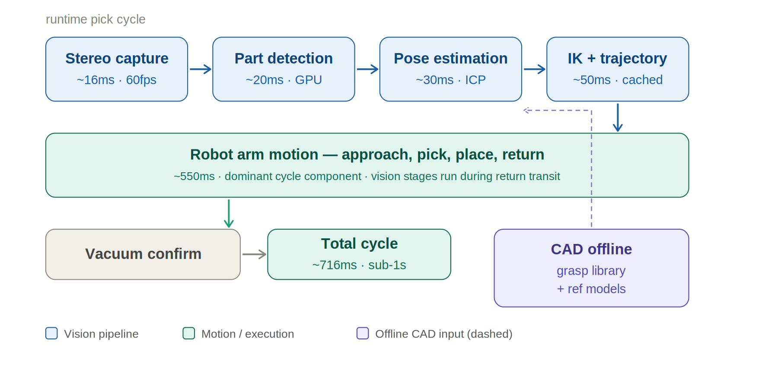

4.2 Offline preparation vs. runtime execution
The offline layer — fed by SolidWorks STL exports — runs once per part and produces the grasp library, synthetic training data, and pose reference models. The runtime layer consumes these as pre-computed assets, making each pick cycle a matching and lookup operation rather than a learning or inference problem.

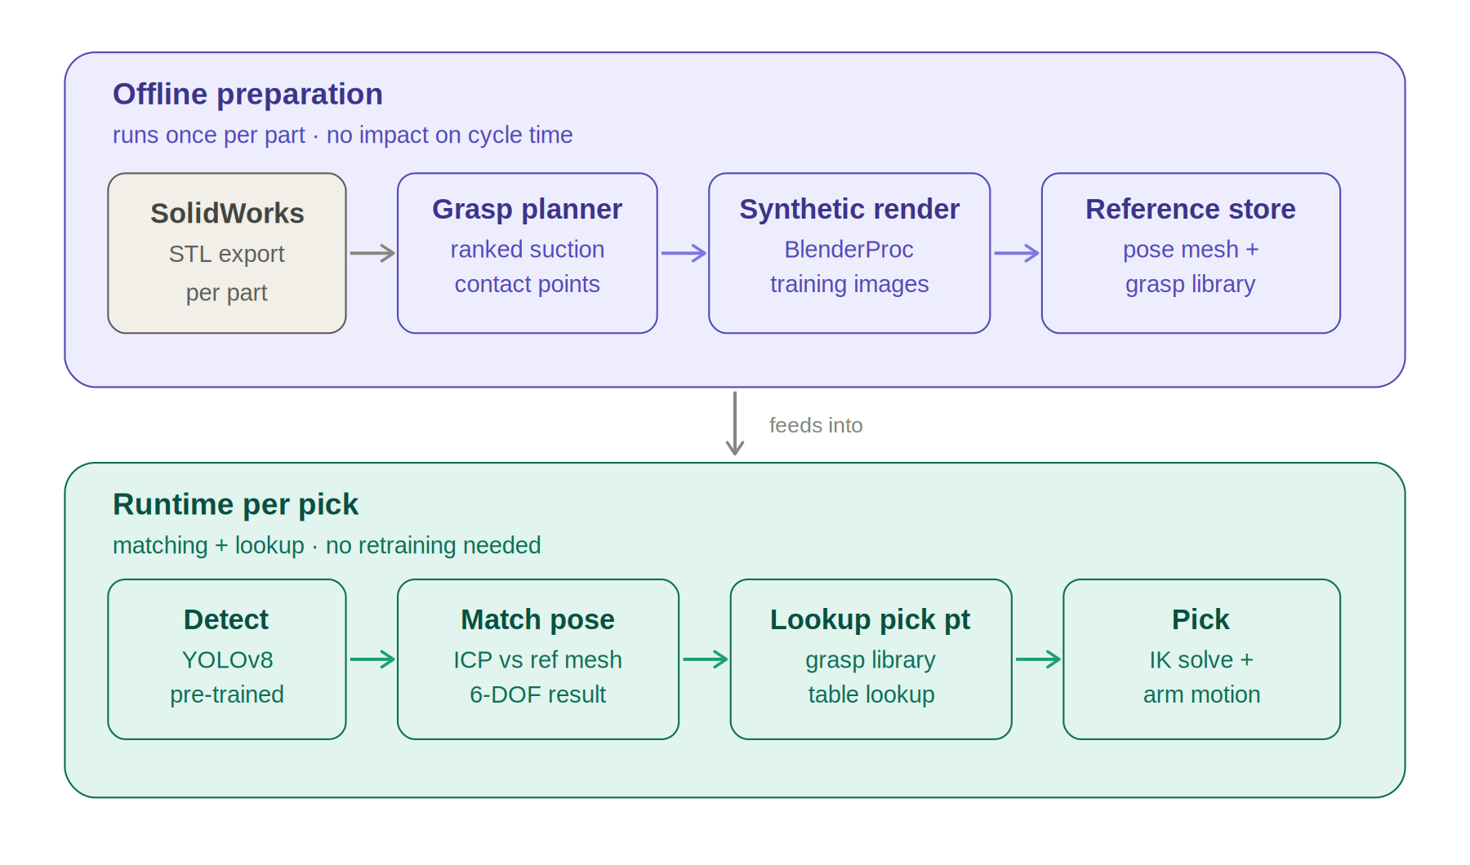

4.3 Full component stack
All system components organized into four runtime layers — hardware, vision stack, motion planning, and diagnostics — alongside the offline CAD preparation pipeline. Dashed arrows show where pre-computed CAD assets feed into the runtime stack.

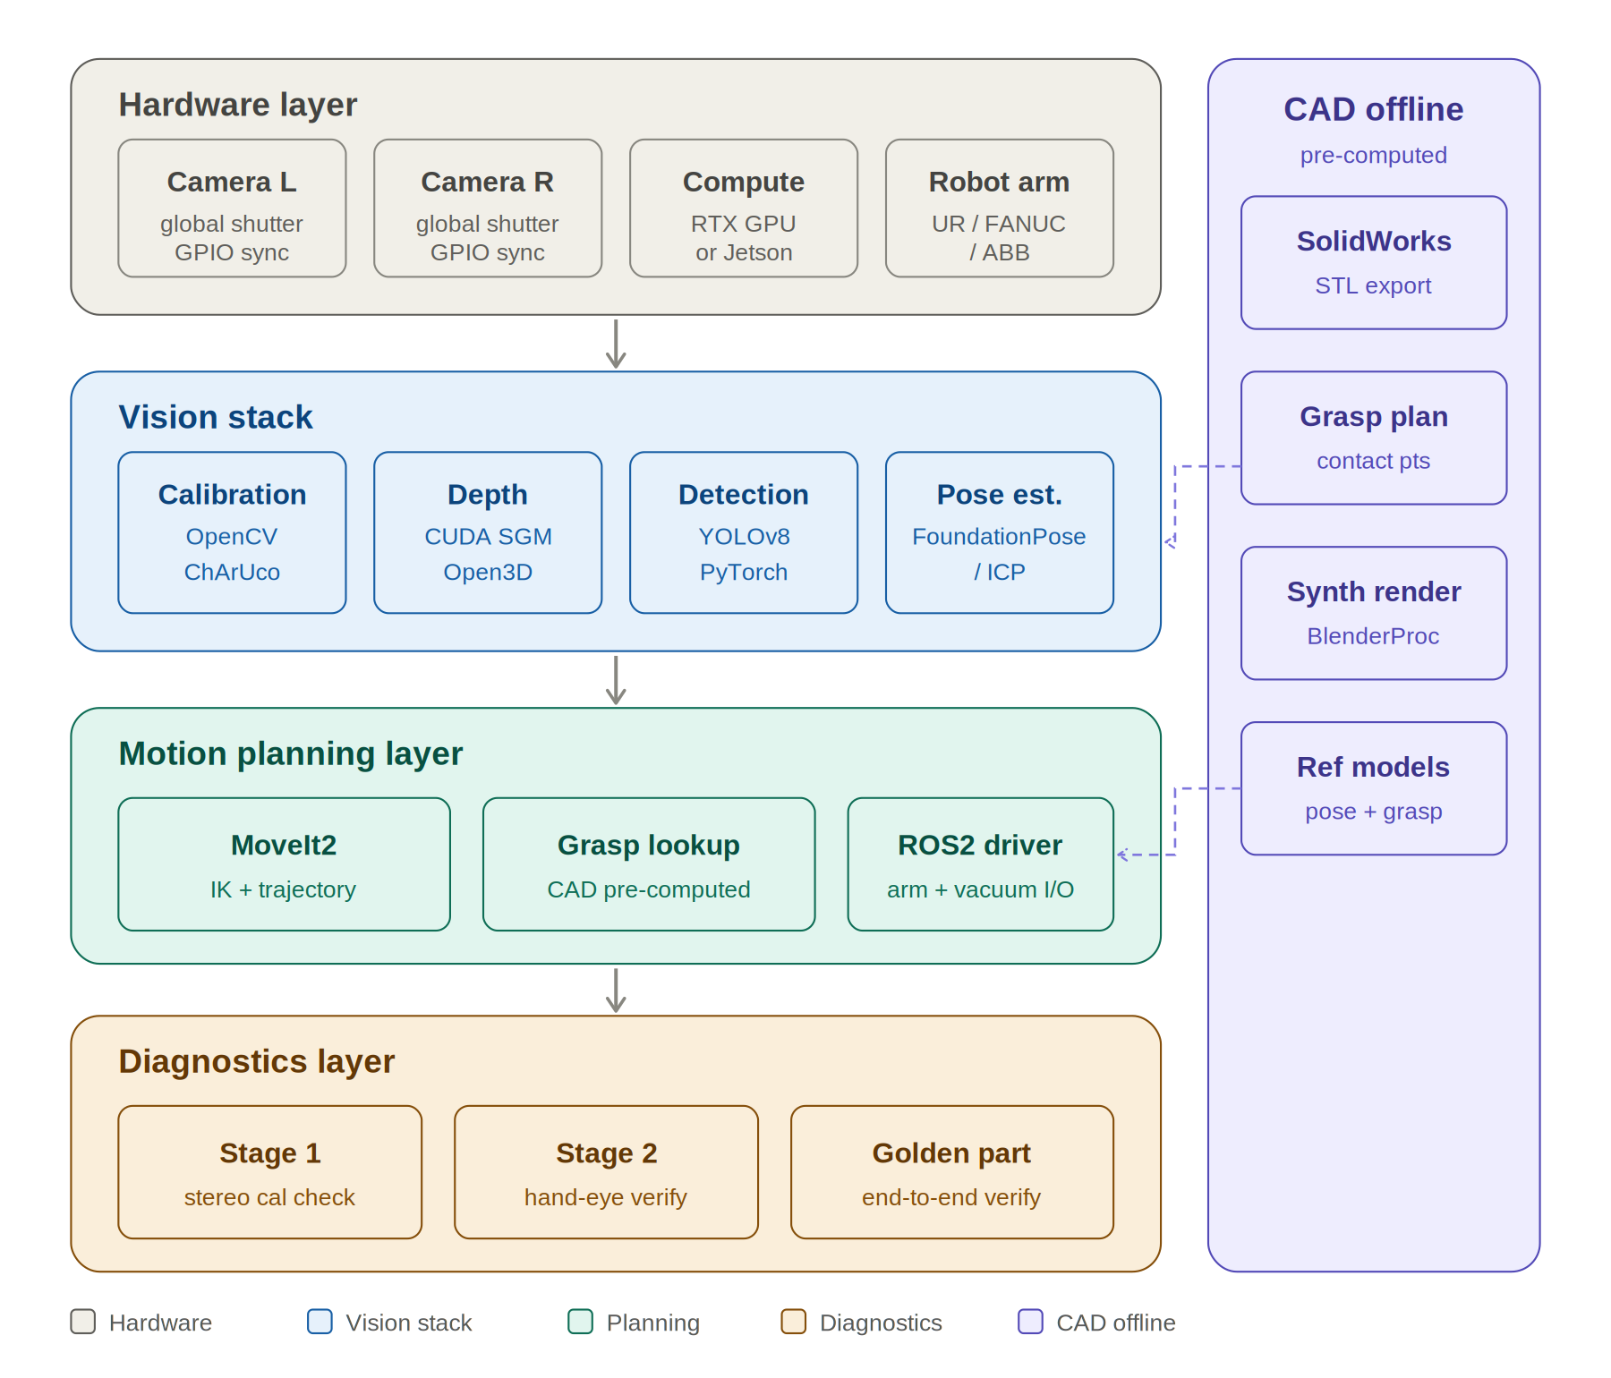

5. Hardware Architecture

5.1 Camera Selection
Two matched industrial cameras are mounted in a fixed stereo baseline configuration above the pick platform. Key requirements:
- Global shutter sensor — eliminates motion blur and geometric distortion when the arm or parts are moving
- Hardware trigger sync — both cameras expose simultaneously via GPIO trigger, ensuring true stereo frame pairs
- High frame rate at reduced resolution — 60-120fps is achievable at 720p, supporting the pipeline latency budget
- C-mount or S-mount lens compatibility — allows working distance and FOV to be tuned to the pick platform geometry

Camera | Sensor | Max FPS @ 720p | Approx. Unit Cost
FLIR Blackfly S USB3 | Sony IMX264 (GS) | 90 fps | $450–$550
Basler ace acA720 | Sony IMX287 (GS) | 522 fps | $380–$480
Allied Vision Alvium | Various (GS) | 60–200 fps | $500–$700

Recommended baseline: 120–180mm separation, calibrated to the working distance of 300–800mm above the pick platform.

5.2 Compute
Vision inference and motion planning run on a single host machine. Minimum recommended specification:
- CPU: Intel Core i7 / AMD Ryzen 7 (8-core) or better
- GPU: NVIDIA RTX 3060 or better — required for CUDA-accelerated stereo matching and neural pose estimation
- RAM: 32GB
- Storage: NVMe SSD for model and point cloud I/O
- OS: Ubuntu 22.04 LTS with ROS2 Humble
For embedded/edge deployment, an NVIDIA Jetson AGX Orin provides sufficient CUDA performance in a compact industrial form factor (~$800 module cost).

5.3 Calibration Target
A ChArUco calibration board (checkerboard + ArUco fiducial markers) is mounted rigidly within the stereo field of view at the edge of the pick platform. It serves dual purpose: initial calibration during commissioning, and ongoing health monitoring during production. The board position is registered to the robot base frame at installation time.

5.4 End Effector
A vacuum suction cup end effector is assumed. Optimal suction grasp points are pre-computed per part from CAD geometry during offline processing. The system uses vacuum pressure feedback to confirm successful pick before executing place motion.

6. Software Architecture

6.1 Stack Overview
The software stack is divided into two execution layers that serve fundamentally different requirements. Understanding this split is important for evaluating the architecture.

The upper layer runs in Python and handles everything that benefits from rapid development, ML library access, and flexibility: orchestration logic, neural network inference (YOLOv8, FoundationPose), 3D processing (Open3D, ICP), diagnostic routines, and configuration management. Most of the components listed in the table below are Python-callable — the table describes the library, not the language.

The lower layer runs in C++ via ROS2 and handles everything where Python physically cannot meet the timing requirements. Python's garbage collector introduces unpredictable pauses of 5–20ms, and its Global Interpreter Lock (GIL) prevents true parallel execution. For hardware I/O and realtime control this is not acceptable: camera GPIO trigger signals require sub-millisecond precision, robot joint command loops run at 500Hz–1kHz and will fault if a packet is late, and industrial communication protocols (EtherNet/IP, RTDE) expect deterministic timing. These functions run in C++ ROS2 nodes regardless of what language the rest of the system uses.

In practice | Python orchestrates the pipeline and dispatches computation. C++ owns the hardware. The boundary sits exactly at the camera trigger, the arm servo loop, and the vacuum I/O — the three points where a 10ms scheduling delay would either miss a frame, drop a part, or fault the controller.

Layer | Component | Purpose
Camera I/O | Spinnaker SDK / Pylon (vendor) | Frame acquisition, hardware trigger sync
Calibration | OpenCV (cv2.aruco) | Stereo intrinsics, extrinsics, ChArUco detection
Depth Compute | OpenCV SGBM / CUDA SGM | Disparity map, point cloud generation
3D Processing | Open3D | Point cloud filtering, ROI extraction, ICP
Part Detection | YOLOv8 (PyTorch) | 2D bounding box, class identification
Pose Estimation | FoundationPose / ICP | 6-DOF pose from RGB-D + CAD reference mesh
Motion Planning | ROS2 MoveIt2 | IK solving, trajectory planning, collision avoidance
Robot Control | ROS2 arm driver (UR, FANUC, etc.) | Joint command execution, vacuum I/O
Diagnostics | Custom Python / ROS2 node | Calibration health monitoring, alerting, logging

6.2 Offline Preparation Pipeline (Per Part)
Each part in the catalog is processed once offline. This work does not affect runtime performance and only needs to be repeated when new parts are added or geometry changes.

3D model acquisition
The pipeline requires an accurate 3D mesh for each part. The source of that mesh does not matter — the system is indifferent to how the geometry was produced. Three acquisition paths are supported:

Method | Best for | Notes
SolidWorks / CAD export | Parts with existing CAD data | Cleanest geometry, known tolerances, no additional equipment needed. Export as STL directly from SolidWorks. This is the assumed path for the initial deployment.
3D scanning | Physical parts without CAD files | A structured light scanner (Revopoint, Artec, or similar) captures a mesh from the physical part in 15–30 minutes at 0.1–0.5mm accuracy — sufficient for suction grasp planning. The right path when CAD files are unavailable, outdated, or locked in a supplier system.
Photogrammetry | Simple convex parts, low budget | 50–100 photographs of a part processed through software such as Meshroom or RealityCapture produce a usable mesh at no hardware cost. Lower accuracy than dedicated scanning and more manual effort, but viable for straightforward part geometries.

Key point | Manufacturers without SolidWorks data are not excluded from this system. A scanning step replaces the CAD export step — the rest of the pipeline is identical. This broadens the addressable market to any manufacturer with physical access to their parts, regardless of whether engineering drawings exist.

Pipeline steps
Once a mesh is available from any of the above sources, each part proceeds through the following offline preparation steps:

Step | Tool | Output
1 | Mesh acquisition | STL mesh per part — sourced from SolidWorks export, 3D scan, or photogrammetry
2 | Grasp planner (GraspIt! / custom) | Ranked list of viable suction contact points and approach vectors, stored per part ID
3 | BlenderProc / NVIDIA Isaac Sim | Synthetic RGB-D training images under randomized lighting and backgrounds for detector training
4 | Open3D mesh sampling | Reference point cloud stored for ICP / FoundationPose lookup at runtime

6.3 Runtime Pick Cycle
The following sequence executes for each pick. Target total cycle time: under 1 second.

# | Step | Target Latency | Notes
1 | Stereo frame capture (hardware-triggered) | ~16ms | 60fps cadence
2 | Part detection via YOLOv8 on RGB image | ~20ms | GPU inference, pre-loaded model
3 | Depth extraction + point cloud (ROI only) | ~30ms | ROI crop avoids full-frame processing
4 | 6-DOF pose estimation vs. CAD reference mesh | ~30ms | ICP or FoundationPose
5 | Suction point lookup + transform to robot frame | ~5ms | Table lookup, no computation
6 | IK solve + trajectory planning | ~50ms | Cached IK library, interpolation
7 | Arm motion — approach, pick, place, return | ~550ms | Dominant cycle time component
8 | Vacuum pressure confirmation | ~10ms | Pick success validation before place
 | Total estimated cycle time | ~711ms | Target: <1 second
Note: Vision and IK computation (steps 1–6) are overlapped with arm return transit from the previous pick, reducing effective latency to near zero for those steps in steady-state operation.

8. Diagnostics & Calibration Health
The system includes a fully automated two-stage diagnostic routine that verifies calibration integrity across the entire vision-to-motion chain. This routine runs on schedule and on anomaly trigger, enabling the system to self-certify its accuracy state without manual intervention.

8.1 Stage 1 — Stereo Camera Calibration Check
With the robot arm parked, the system captures frames of the fixed ChArUco calibration board and evaluates:
- Stereo reprojection error (pixels) — deviation of detected corners from expected positions given stored intrinsics
- Epipolar constraint error — verifies stereo rectification alignment
- Board pose delta — observed board position vs. known installed position

Thresholds | Reprojection error > 0.5px: warning logged. > 1.0px: automatic recalibration triggered. > 2.0px or board pose delta > 3mm: operator alert, production paused.

8.2 Stage 2 — Hand-Eye Calibration Check
The arm moves through a pre-defined sequence of N known poses within the working envelope. At each pose, the camera observes the calibration board and the system compares the observed board position to the expected position in robot base frame coordinates. This verifies:
- Camera-to-robot coordinate transform integrity
- Robot joint accuracy and TCP (tool center point) calibration
- Calibration validity across the actual working envelope, not just at home position

A camera calibration check that passes Stage 1 but fails Stage 2 indicates the camera mount has shifted relative to the robot — a fault that stereo reprojection error alone cannot detect.

8.3 Stage 3 — Golden Part Verification (Optional)
An extended diagnostic places a known calibration part at an exact registered XYZ location and runs the full pick pipeline. This closes the entire loop from perception through execution and validates detection, pose estimation, and motion accuracy simultaneously. Pick success is confirmed via vacuum sensor. Vision-estimated position is logged against ground truth.

8.4 Diagnostic Schedule
Trigger | Stages Run | Action on Failure
System startup | 1 + 2 + 3 | Hold production pending operator review
Every 500 pick cycles | 1 only (fast) | Log warning; trigger Stage 2 if threshold breached
Every 5,000 pick cycles | 1 + 2 + 3 | Operator notification if outside tolerance
Pick miss rate > 2% | 1 + 2 + 3 | Immediate diagnostic; production paused
After any E-stop event | 2 + 3 | Required sign-off before production resumes
After maintenance flag cleared | 1 + 2 + 3 | Full sign-off required

8.5 Diagnostic Logging
All diagnostic runs produce structured log entries including timestamp, reprojection error, hand-eye XYZ/rotation error, golden part pick result, and pose delta. Error values are trended over time, enabling predictive maintenance scheduling based on drift rate rather than simple pass/fail thresholds.

9. System Features

9.1 Core Features
- Sub-second pick cycle — Sub-second pick cycle
- Known parts catalog — Support for a defined catalog of known parts via SolidWorks CAD-derived reference models
- Stereo depth vision — Stereo depth vision with hardware-synchronized global shutter cameras
- 6-DOF pose estimation — 6-DOF pose estimation using ICP and/or FoundationPose against CAD meshes
- CAD-derived grasp library — Optimal suction grasp point selection from pre-computed per-part grasp libraries
- Pick confirmation — Vacuum pressure pick confirmation before place execution
- Self-certifying calibration — Automated two-stage calibration diagnostics with self-recalibration capability
- Telemetry logging — Structured telemetry and error trend logging

9.2 Operational Features
- New parts added to the catalog via SolidWorks STL import — no robot reprogramming required
- Camera-vendor-agnostic above the frame acquisition layer — cameras can be swapped without software changes
- Robot-agnostic motion layer via ROS2 MoveIt2 — supports UR, FANUC, KUKA, ABB, and others with ROS2 drivers
- Configurable diagnostic thresholds and scheduling via config file — no code changes required
- Pick miss rate monitoring with automatic diagnostic escalation
- Operator alert interface via configurable notification channel (email, SMS, SCADA I/O)

9.3 Optional / Future Features
- Mixed-part platform support — multiple part types present simultaneously, single-pass detection and sequenced picking
- Bin picking mode — parts presented in a bin with random orientations and possible overlap
- Quality inspection integration — post-pick image capture for surface defect classification
- OPC-UA interface — integration with factory MES/SCADA systems
- Digital twin synchronization — live pick state mirrored to simulation environment

10. Estimated Cost
The following is a good-faith estimate based on currently available component pricing. Final costs are subject to camera model selection, robot platform, and site-specific installation requirements.

10.1 Hardware
Item | Qty | Unit Cost | Total
Industrial global shutter cameras (e.g. FLIR Blackfly S) | 2 | $500 | $1,000
C-mount lenses (matched pair) | 2 | $150 | $300
Stereo mount / baseline rig (custom or off-shelf) | 1 | $300 | $300
ChArUco calibration board (rigid, laminated) | 1 | $100 | $100
Vision compute host (RTX 3060, i7, 32GB RAM) | 1 | $1,500 | $1,500
GPIO sync wiring / trigger hardware | 1 | $150 | $150
Cabling, mounts, enclosure | — | — | $400
Hardware Subtotal |  |  | ~$3,750

10.2 Software Development
Workstream | Est. Effort | Notes
Stereo calibration pipeline + diagnostic harness | 2 weeks | OpenCV ChArUco tooling
Depth computation + point cloud pipeline | 2 weeks | CUDA SGM tuning for part surfaces
Offline CAD processing tooling (per-part prep) | 1 week | Grasp planner + synthetic data gen
Part detection model training + validation | 2 weeks | YOLOv8 on synthetic dataset
Pose estimation integration (ICP / FoundationPose) | 2 weeks | Per-part validation against ground truth
ROS2 integration + MoveIt2 motion planning | 2 weeks | Robot-specific driver config
Diagnostics system + telemetry logging | 1 week | Scheduling, thresholds, alerting
System integration, commissioning, testing | 2 weeks | On-site or in-lab acceptance testing
Total Development Estimate | ~14 weeks | 1 senior CV/robotics engineer

All software components utilize open-source libraries with no per-deployment licensing costs. The only recurring software cost is maintenance and support, which can be scoped as a separate engagement.

Cost Note | Robot arm, end effector, pick platform, and facility integration are excluded from this estimate and assumed to be provided or separately scoped by the client.

10.3 Proof of Concept Phase
Prior to full system integration, a low-cost proof of concept is recommended using 3D printed replicas of catalog parts. Parts can be printed directly from existing SolidWorks STL files at minimal cost and used to validate the end-to-end pipeline — CAD-to-grasp-library processing, stereo depth accuracy, pose estimation against the reference mesh, and suction pick mechanics — before production parts or a live robot cell are required. This approach surfaces integration issues early, reduces rework risk, and provides a working demonstration suitable for internal sign-off or stakeholder review.

POC Item | Est. Cost | Est. Effort
3D printed part replicas (FDM filament, print time) | $200–$500 | 1–2 days print time
Benchtop stereo rig (camera mount, calibration board) | ~$400 | 1 day setup
Pipeline validation against printed parts | Included | 2–3 weeks
POC Total | ~$600–$900 | 2–3 weeks

11. Risks & Mitigations
Risk | Likelihood | Mitigation
Reflective or dark part surfaces degrade depth quality | Medium | Polarized lighting, matte fixture coating, or supplemental IR projector
Camera mount shift after maintenance or collision | Medium | Stage 2 diagnostic detects mount shifts that Stage 1 misses; auto-halt on threshold breach
New parts added to catalog require re-processing | High (routine) | Offline CAD pipeline is scripted and documented; new parts added in under half a day
Overlapping or touching parts at pick time | Low–Medium | Instance segmentation model handles occlusion; pick order logic avoids unstable stacks
Stereo depth fails on texture-less surfaces | Medium | Active IR dot projector adds texture; passive stereo reserved for textured parts

Development velocity note | The effort estimates above reflect a conventional engineering timeline. A meaningful portion of the implementation work — ROS2 integration scaffolding, OpenCV calibration tooling, diagnostic harness code, configuration UI boilerplate, and synthetic data generation scripting — is well-suited to LLM-assisted development. A 20–30% reduction in effort on implementation-heavy workstreams is a realistic expectation, potentially compressing the 14-week estimate to 10–11 weeks for a well-structured engagement. Architecture decisions, hardware integration, and on-site commissioning remain full engineering-hours work and are not materially accelerated by this approach.

12. High-Level Project Timeline
Phase | Duration | Deliverables
1 | Discovery & Hardware Procurement | Camera selection finalized, hardware ordered, part catalog STLs received
2 | Offline CAD Pipeline & Model Training | Grasp libraries, synthetic datasets, trained detector per part
3 | Vision Stack Development | Stereo calibration, depth pipeline, pose estimation validated in lab
4 | Robot Integration & Motion Planning | ROS2 integration, MoveIt2 config, pick cycle running end-to-end
5 | Diagnostics & Hardening | Diagnostic routines implemented, telemetry logging, alerting configured
6 | On-Site Commissioning & Acceptance | System installed, acceptance test passed, documentation delivered

13. Next Steps
To move this project forward, the following information and decisions are needed from the client:
- Parts catalog — count of distinct parts, SolidWorks STL files or native CAD models
- Part surface characteristics — material, finish, color (critical for depth camera performance planning)
- Robot arm model — determines ROS2 driver, IK configuration, and payload/reach validation
- Platform geometry — dimensions, camera mounting constraints, working distance
- Throughput target — picks per hour, single or multi-part platform at pick time
- Site environment — lighting conditions, ambient IR sources, temperature range

Upon receipt of the above, we will provide a refined effort estimate, finalized hardware bill of materials, and a detailed project schedule.

PART II
Market Opportunity & Productization Path
The commercial case, go-to-market strategy, and industry partnerships that bring this system to the mid-market manufacturing segment

14. The Market Opportunity
Manufacturing automation is growing rapidly, driven by rising labor costs, reshoring of production, and the shift from high-volume dedicated lines to high-mix flexible cells. Machine vision is at the center of that shift — but the current market structure leaves a large and underserved segment without a viable solution.

14.1 The Incumbent Problem
The established players in manufacturing pick-and-place vision — Cognex, Keyence, Mech-Mind, Fizyr, and the vision bundles offered by robot OEMs such as FANUC, KUKA, and ABB — share a common profile: they were designed for Tier 1 manufacturers with large automation teams, high-volume single-SKU production, and capital budgets to match. Their pricing, integration complexity, and support models reflect that origin.

Incumbent Weakness | Why It Matters
High software licensing cost | Per-deployment or per-robot licensing from Cognex and Keyence adds significant recurring cost that does not scale down for smaller operations. Mid-market manufacturers pay enterprise prices for capabilities they do not fully use.
Integrator dependency | Most enterprise vision systems require certified systems integrators for installation, configuration, and part changeovers. This adds weeks of lead time and ongoing service cost that makes frequent changeovers economically prohibitive.
Rigid to part changes | Traditional vision systems require manual reprogramming when a new part is introduced. For high-mix manufacturers running dozens or hundreds of SKUs, this creates a permanent engineering bottleneck.
2D-limited at entry price | Affordable vision systems rely on single-camera 2D capture, which cannot determine true 3D part pose. The result is slow, conservative pick motions and high failure rates on any part with variable presentation orientation.
Vendor lock-in | Proprietary hardware, closed SDKs, and single-vendor ecosystems mean manufacturers are dependent on the vendor's roadmap, pricing, and continued support. Intel's wind-down of RealSense is a recent example of this risk materializing.

14.2 The Underserved Segment
The gap in the market is not at the top or bottom — it is in the middle. Small and mid-market manufacturers in the $20M–$500M revenue range represent a large and growing segment of North American and European manufacturing. They share a consistent profile:
- Running mixed-SKU production with frequent changeovers — often 10 to 100+ distinct part numbers
- Operating without a dedicated automation engineering team
- Already using SolidWorks or equivalent CAD tools — part geometry data exists and is maintained
- Priced out of enterprise vision solutions, but demanding more than toy-grade single-camera systems can deliver
- Under pressure to automate due to labor availability, wage inflation, and competitive reshoring dynamics

This segment is currently making one of three choices: deploying unreliable 2D vision and absorbing the pick failure cost, hiring manual labor to do what automation should handle, or deferring automation entirely. All three represent an unmet need and a commercial opportunity.

14.3 Why This Architecture Wins in That Segment
Differentiator | Why It Matters to Mid-Market
CAD-to-deployment pipeline | Manufacturers already have SolidWorks models for every part. The ability to upload an STL and have the system generate its own grasp library and pose reference model — without manual teach programming — directly eliminates the integrator bottleneck that makes part changeovers expensive.
True 3D stereo vision at accessible cost | Stereo depth with hardware-synchronized industrial cameras delivers enterprise-grade 3D pose accuracy at a hardware cost an order of magnitude below structured-light industrial cameras. The performance gap versus incumbent 2D systems is stark and demonstrable.
Open-source stack, no licensing | No per-deployment software licensing means the cost model scales favorably. A manufacturer adding a second cell does not pay a second license fee. This is a structural pricing advantage over Cognex and Keyence.
Self-certifying diagnostics | Automated calibration health monitoring with self-recalibration reduces dependence on service visits. A plant manager can trust the system is working without an engineer verifying it daily. This is a support cost reduction that is directly visible to the buyer.
Vendor-agnostic hardware | No dependence on a single camera vendor or robot OEM. Works with UR, FANUC, KUKA, ABB, and others via ROS2. Camera hardware can be swapped without software changes. This is a direct counter to the lock-in objection that mid-market buyers have been burned by before.

15. Productization Path
The technology described in this proposal is a strong foundation for a commercial product, but there is meaningful work between a repeatable integration project and a shippable product. The following outlines what that path looks like and where partner leverage is highest.

15.1 What Needs to Be Built
Investment Area | Description | Priority
No-code configuration UI | Web-based wizard allowing a process engineer to add a new part by uploading an STL. System handles grasp planning, synthetic rendering, and model preparation without a terminal. | Highest — unlocks the mid-market without an engineer on-site
Defined hardware SKU | Designed stereo head with fixed baseline, industrial enclosure, single cable out, factory calibrated. Ships as a product with a model number and datasheet. | High — required to sell through integrators or distribution
PLC / SCADA integration | OPC-UA and EtherNet/IP bridge so the system talks natively to Siemens, Rockwell, and Mitsubishi controllers. Without this, every installation requires a custom interface by the customer's controls engineer. | High — deal-breaker for many manufacturing buyers
Performance dashboard | Operator-facing display showing picks per hour, success rate, calibration health, and downtime events. Also serves as the remote support interface. | Medium — accelerates adoption and reduces support cost
Certification & compliance | CE marking, UL listing, IP-rated enclosures, and safety-rated I/O as required by target verticals. Scope varies by industry. | Medium — required before EU or regulated industry deployment

15.2 Three-Phase Go-to-Market
The most capital-efficient path to product is to generate revenue while building, using early integration projects to validate what is truly repeatable before investing in productization infrastructure.

Phase | Horizon | Activity | Outcome
1 | Now — 18 months | Sell 3–5 integration projects to mid-market manufacturers with similar part profiles. Charge full custom-project rates. Identify what is repeatable vs. custom each time. | Revenue, real-world validation, and a clear picture of what to productize
2 | 12 — 30 months | Build the no-code configuration UI, hardware SKU, and OPC-UA bridge. Package as a product with a defined price. Engage 2–3 regional systems integrators as launch channel. | First commercial product shipments through integrator channel
3 | 24+ months | Develop formal integrator certification program. Integrators handle installation and first-line support. Focus shifts to product development and second-line support. Expand verticals. | Scalable distribution model, recurring revenue, growing installed base

15.3 Competitive Positioning
The clearest positioning is directly below Mech-Mind and Fizyr on price, and directly above 2D entry-level systems on capability. The narrative is straightforward:

Enterprise Systems (Cognex, Mech-Mind, FANUC iRVision) | This System | Entry-Level 2D (single-camera, low-cost)
High accuracy, high cost, integrator-dependent, rigid to change | 3D stereo accuracy. CAD-native configuration. No licensing. Self-maintaining. Mid-market price. | Low cost, slow, unreliable, 2D only, fails on part variation

15.4 Go-to-Market Partnerships
Building the product is one challenge. Reaching the right buyers efficiently is another. The most effective path to market for a manufacturing automation product is not direct sales — it is building a network of partners who already have the customer relationships, brand credibility, and distribution infrastructure in the segments we are targeting. Three partnership categories are highest priority:

Partner Type | Who & Why | What They Provide
Camera manufacturers | FLIR, Basler, Allied Vision, and Lucid Vision all actively seek application partners who build validated systems on their hardware. A reference design built on their cameras is a sales tool for them. | Co-marketing, joint application notes, inclusion in their robotics ecosystem directories, potential preferred pricing on hardware for our deployments
Robot arm manufacturers | Universal Robots, FANUC, and Techman Robot all maintain certified application partner programs. Vision is a common gap in their ecosystem — partners who solve it get promoted to their installed base. | UR+ / FANUC Partner listings, referrals from their sales teams to customers who need vision capability, joint trade show presence, access to their OEM customer networks
Systems integrators & VARs | Regional automation integrators deploy robots but typically resell third-party vision systems. A product that is easier to configure and more cost-effective than Cognex gives them a competitive advantage with their clients. | Last-mile installation and commissioning capability, existing manufacturing customer relationships, recurring service revenue model that aligns with our support needs
Industry bodies & channels | A3 (Association for Advancing Automation), SME (Society of Manufacturing Engineers), and PMPA (Precision Machined Products Association) serve the exact mid-market manufacturing segment we are targeting. | Publication in member communications, speaking opportunities at events like Automate and IMTS, introductions to member companies actively evaluating automation

These partnerships are not exclusive and are not complex to initiate. Camera and robot arm manufacturers in particular have structured programs with defined on-ramps. The first step is completing a reference deployment — one validated installation on a real manufacturing line — and using that as the basis for partner program applications and co-marketing conversations.

Partnership Principle | We do not need to own every part of the customer relationship. Camera vendors want their hardware specified. Arm manufacturers want their robots sold. Integrators want proven products to deploy. Positioning this system as the vision layer that makes all of those relationships more successful is a lower-cost, faster path to market than building a direct sales force.

16. Recommendation & Next Steps
This proposal makes the case for investing in a custom stereo vision pick-and-place system — both as an internal capability and as the foundation for a commercial product in an underserved market segment. The technical architecture is sound, the cost structure is favorable, and the market gap is real and growing.

The recommended path forward is a phased approach that builds internal capability first, then productizes what is proven:
- Approve Phase 1 — fund a first internal deployment against a defined manufacturing use case with a clear acceptance criteria and cycle time target
- Initiate camera and arm partner conversations in parallel — apply to UR+, FLIR robotics partner program, and Basler application partner program using the reference deployment as qualification
- Identify 2–3 external pilot candidates — mid-market manufacturers in adjacent verticals who would benefit from early access in exchange for reference customer status
- Scope productization investment — following Phase 1 completion, assess the no-code configuration UI and OPC-UA integration as the next development priorities for commercial product readiness

The window for this opportunity is open but not permanent. Mech-Mind and others are moving down-market. The advantage of moving now is establishing reference deployments, partner relationships, and market presence before the mid-market segment becomes contested.

Recommended action: approve Phase 1
A single validated deployment is the foundation for the product, the partner relationships, and the commercial opportunity described in this document.

ADDENDUM
Glossary of Terms

The following definitions are provided as a reference for readers who are less familiar with the computer vision, robotics, or software terminology used in this document. Definitions are written in plain language and avoid technical jargon where possible.

Vision & Depth Sensing
Term | Definition
Stereo vision | A depth-sensing technique that uses two cameras positioned a fixed distance apart — similar to human eyes — to calculate how far away objects are by comparing the slight difference between the two images. The greater the difference in position of an object between the two images, the closer it is to the cameras.
Structured light | A depth-sensing method that projects a known pattern of infrared light (dots, stripes, or grids) onto a scene, then measures how the pattern deforms across object surfaces to calculate depth. Used by cameras such as the Intel RealSense to improve accuracy on surfaces that lack natural texture.
Active stereo | A hybrid approach combining stereo cameras with a projected infrared dot pattern. The projected pattern adds artificial texture to smooth or featureless surfaces, making stereo depth calculation possible where passive stereo would fail. The Intel RealSense D435i uses active stereo.
Point cloud | A collection of thousands or millions of individual 3D coordinate points that together represent the surface geometry of objects in a scene. Generated from depth camera data, a point cloud is the primary input for 3D pose estimation algorithms.
Global shutter | A camera sensor design that captures all pixels in a frame simultaneously, rather than scanning across the image row by row. This eliminates motion blur and geometric distortion when objects or the camera itself are moving — critical for robotics applications where vibration is common.
Hand-eye calibration | The process of precisely measuring and recording the spatial relationship between the camera and the robot arm. Without accurate hand-eye calibration, the system cannot correctly translate a position detected in the camera image into a position the robot can move to. This calibration must be maintained and periodically verified.
ChArUco board | A calibration target combining a checkerboard pattern with uniquely identifiable marker squares (ArUco markers). Used to calibrate camera intrinsics and stereo geometry. The combination of checkerboard precision and marker identity makes detection reliable even with partial occlusion or at oblique angles.
Depth of field / working distance | The range of distances from the camera over which depth measurements are accurate. For this system, the working distance is approximately 300–800mm above the pick platform — the vertical range within which parts must be presented for reliable detection and pose estimation.
Gaussian splatting (3DGS) | An emerging technique for representing 3D scenes using millions of small semi-transparent ellipsoids (Gaussian splats) rather than traditional triangles or point clouds. Each splat encodes position, shape, color, and how the surface appears from different viewing angles — including reflections. This makes it particularly promising for handling reflective or texture-less parts that defeat conventional depth cameras. Currently a near-future capability for this system.

Software & Algorithms
Term | Definition
6-DOF (six degrees of freedom) | The complete description of an object's position and orientation in 3D space: three translational positions (X, Y, Z) and three rotational orientations (roll, pitch, yaw). A full 6-DOF pose tells the robot not just where a part is, but exactly how it is tilted and rotated — enabling precise suction cup placement.
Pose estimation | The process of determining the 6-DOF position and orientation of a known object in a camera image or point cloud. In this system, pose estimation compares the observed part against a pre-stored reference model derived from the SolidWorks CAD mesh to determine exactly how the part is positioned.
ICP (Iterative Closest Point) | A standard algorithm for aligning two point clouds by repeatedly finding the closest matching points and adjusting the alignment until convergence. Used in this system to match the observed 3D shape of a part against the CAD reference mesh and determine its precise pose. Fast and reliable when a good initial estimate is available.
FoundationPose | A state-of-the-art pose estimation model developed by NVIDIA that accepts a CAD mesh and a single RGB-D camera frame and returns a 6-DOF pose estimate. It is particularly robust on objects with limited texture or complex geometry, and is used in this system as an alternative or complement to ICP for challenging parts.
YOLOv8 | A widely used real-time object detection model that identifies and locates objects within a camera image by drawing bounding boxes around them. In this system it is used to detect which part is present and where it is in the image before the 3D pose estimation step begins. It runs on a GPU and produces results in approximately 20 milliseconds.
CUDA / CUDA SGM | CUDA is NVIDIA's parallel computing platform that allows algorithms to run on a graphics processing unit (GPU) rather than a standard CPU, dramatically accelerating computation. CUDA SGM (Semi-Global Matching) is a CUDA-accelerated algorithm for computing depth from stereo image pairs — the step that converts two camera images into a 3D point cloud.
Synthetic training data | Artificially generated images created by rendering 3D models (from SolidWorks STL files) in a simulation environment under randomized lighting, backgrounds, and orientations. Used to train the part detection model without requiring thousands of real photographs. Tools such as BlenderProc and NVIDIA Isaac Sim automate this process.
STL file | A standard 3D mesh file format exported from CAD tools including SolidWorks. Represents the surface geometry of a part as a collection of triangular faces. Used in this system as the source of truth for part geometry — feeding the grasp planner, pose reference model, and synthetic data renderer.
Open3D | An open-source library for processing 3D data including point clouds and meshes. Used in this system for point cloud filtering, region-of-interest extraction, and running ICP pose estimation.
OpenCV | The most widely used open-source computer vision library. Used in this system for stereo camera calibration, ChArUco board detection, image processing, and disparity map computation.
OPC-UA / EtherNet/IP | Industrial communication protocols used to connect automation systems to factory control infrastructure. OPC-UA is a platform-independent standard widely used in Europe and modern facilities. EtherNet/IP is common in North American manufacturing and is native to Rockwell (Allen-Bradley) control systems. Supporting both allows the vision system to integrate with the PLC and SCADA systems already present on the factory floor.

Robotics & Motion
Term | Definition
IK (Inverse Kinematics) | The mathematical process of calculating what joint angles a robot arm must adopt to position its end effector (the tool at the tip of the arm) at a specific location and orientation in space. Given a target pick position from the vision system, IK determines the exact movements each joint of the arm must make to reach it. Pre-computing and caching common IK solutions significantly reduces cycle time.
ROS2 (Robot Operating System 2) | An open-source middleware framework that provides standardized communication, drivers, and tools for robotics systems. ROS2 is the industry standard for research and increasingly for production robotics. It allows the vision system, motion planner, and robot arm controller to communicate using a common interface, and supports most major robot arm brands through published driver packages.
MoveIt2 | The standard motion planning library for ROS2. Given a target position and the robot's current joint configuration, MoveIt2 computes a smooth, collision-free trajectory for the arm to follow. It handles IK solving, obstacle avoidance, and trajectory optimization, and supports most major industrial robot arms through configurable driver packages.
End effector | The tool attached to the end of the robot arm that physically interacts with parts. In this system the end effector is a vacuum suction cup — a pneumatic device that forms an airtight seal against a part surface and holds the part using negative air pressure. The vision system selects the optimal contact point on each part for suction cup placement based on pre-computed grasp analysis.
TCP (Tool Center Point) | The defined reference point at the tip of the robot's end effector — in this case the center of the suction cup face. All motion planning coordinates are expressed relative to the TCP. Accurate TCP calibration is required for the robot to reliably place the suction cup at the exact contact point identified by the vision system.
Pick cycle | The complete sequence of operations required to move one part from the pick platform to its destination: camera capture, part detection, pose estimation, motion planning, arm approach, vacuum pick, arm transit to place location, vacuum release, and arm return. This system targets a total pick cycle time of under one second.
Grasp planning | The offline process of analyzing a part's 3D geometry to identify all viable locations where a suction cup can form a reliable seal — flat or gently curved surfaces with sufficient area, away from edges, holes, or features that would break the vacuum. This analysis is run once per part from the SolidWorks mesh and stored as a ranked list of contact points used at runtime.
OEE (Overall Equipment Effectiveness) | A standard manufacturing metric expressing the percentage of planned production time that is truly productive. Calculated as the product of availability, performance, and quality rates. A vision system that reduces pick failures and unplanned downtime directly improves OEE — the primary metric by which manufacturing buyers evaluate automation investments.
E-stop (Emergency Stop) | A safety mechanism that immediately halts all robot motion when triggered — either manually by an operator or automatically by the control system in response to a fault. This system runs a full diagnostic verification before production resumes after any E-stop event to ensure calibration has not been disturbed.

